1. Follow the 0/1 knapsack problem solution provided in class to solve the following problem: (6 points). The sack’s weight limit is 11. That is w = 11 (5 points).



|  |  |  |
| --- | --- | --- |
| Item | wi | vi |
| I1 | 1 | 5 |
| I2 | 3 | 4 |
| I3 | 5 | 8 |
| I4 | 2 | 6 |

|  |  |  |  |  |  |  |  |  |  |  |  |  |
| --- | --- | --- | --- | --- | --- | --- | --- | --- | --- | --- | --- | --- |
| **Item** | **0** | **1** | **2** | **3** | **4** | **5** | **6** | **7** | **8** | **9** | 10 | 11 |
| **1** | 0 |  |  |  |  |  |  |  |  |  |  |  |
| **2** | 0 |  |  |  |  |  |  |  |  |  |  |  |
| **3** | 0 |  |  |  |  |  |  |  |  |  |  |  |
| **4** | 0 |  |  |  |  |  |  |  |  |  |  |  |

|  |  |  |  |
| --- | --- | --- | --- |
| 0 |  |  |  |
|  | 0 |  |  |
|  |  | 0 |  |
|  |  |  | 0 |

1. You are given the input p = <5, 2, 3, 10, 20>, populate the m,1 based and on the right, according to the MATRIC-CHAIN-ORDER(p) algorithm. Show your calculation for m[1,6], which should be 1484 (4 points).

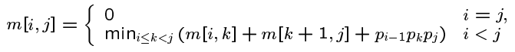

1. DFS <http://www.cs.cornell.edu/courses/cs2112/2012sp/lectures/lec24/lec24-12sp.htmlA>. Mark the timestamps for each node.

